**March 1**: *Arrive at Hilo, International Airport. Shuttle Service from airport to the Hilo Hawai‘ian Hotel (or similar)*

**March 2**: *Brief Orientation after breakfast, depart for Hawai‘i Volcanoes National Park, lunch at the Rim Restaurant Historic Volcano House –Tour Volcanoes National Park (****B,L,D)***

**March 3**: *Ukulele workshop with Brad Bordessa, lunch Punalu‘u Bakery—stop by Pulalu‘u Sand Beach—and possibly see the Hawai‘ian Green Sea turtles* ***(B,L,D)***

**March 4 :** *Visit to Honuala Ukulele Gallery, free time to explore Kailua-Kona town* ***(B)***

**March 5**: *Check out of the Hotel for airport departure, flight from Hilo to O‘ahu. Lunch at a local restaurant with visit to Pearl Harbor and USS Arizona Memorial.*

*Check in at the Waikīkī* *Resort Hotel* ***(B,L)***

**March 6**: *Morning Workshop with Roy Sakuma. After lunch meet a local ‘Ukulele Rising Star. In the evening check out a local ‘ukulele musician playing in Waikīkī or Optional Lū‘au* *dinner & show for a fee)* ***(B)***

**March 7**: *Lecture or workshop with Bruce Shimabukuro (tba) After lunch on your own, Performance at Honolulu Festival or visit the Ukulele Site in Honolulu. In the evening check out a local ‘ukulele musician playing in* *Waikīkī* *(Optional Lū‘au* *dinner & show for a fee)* ***(B)***

**March 8**:  *Performance at Honolulu Festival or Visit Ukulele Site in Honolulu. Lunch on your own. Honolulu Festival Parade. Farewell Dinner with Evening ‘Ukulele Kanikapila* ***(B,D)***

**March 9**: *Breakfast at leisure. Check out of hotel. Transfers provided to Honolulu Airport for return flight home* ***(B)***

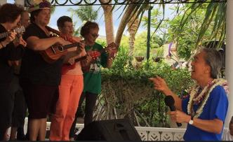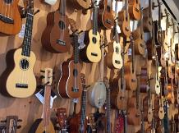

***\* Major Credit Cards Accepted***

***\* Non-refundable deposit of $500 USD per person due at time of booking***

***\* Final payment is due by December 30, 2019***

***\* Proof of travel insurance required***

***\* Price excludes international flights; passport and personal***

***expenses-laundry, telephones, soft and alcoholic beverages***

***\* Minimum participant requirement***

#4269684

***Contact us at:***

**613 831 6150 * 1 800 461 8603**

**ottawawest.cruiseholidays.com**

**captain@bellnet.ca**